**Testplan ZOUDIO AIO438**

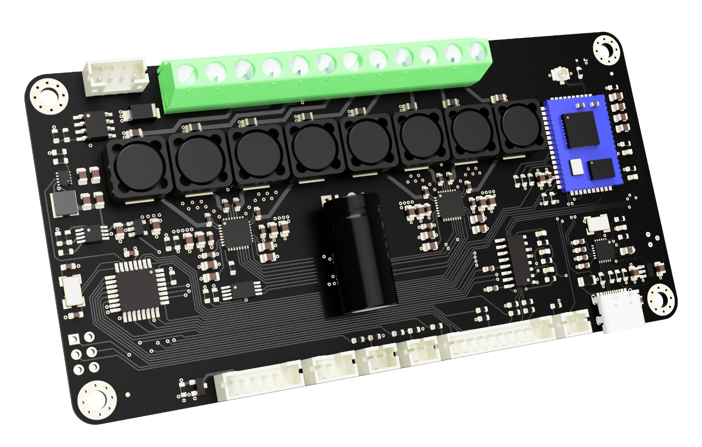

Table of contents

Outline 2

System diagram 2

Testpoint PCB (TPCB) details 2

Windows PC details: 2

TPCB pin mapping: 3

Test routine 3

# Outline

The AIO438 developed by Zoudio is an all-in-one amplifier with Bluetooth and DSP. The goal of this document is to detail a testplan which is used to program and test the amplifier PCBA after production.

# System diagram

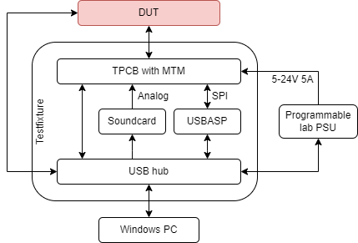

# Testpoint PCB (TPCB) details

The TPCB is the interface between the testcircuitry and the device under test (DUT). Ingun wireless probes will connect to the DUT to the testpoints on the TPCB. The bottom side of the TPCB contains the following:

* Power input terminal for 5-24V from a lab PSU to power the DUT
* PCI-e slot for a MTM-USBSTEM
* USB-C connector for communication with the MTM module.
* 12V input to power the USBSTEM.
* 3.5mm jack to receive analog signals and pass them on to the DUT.
* 4 high power resistor banks to simulate a speaker load on all amplifier channels
* Header for USB-ASP programmer

# Windows PC details:

The Windows PC runs a combination of the following scripts/programs:

* Avrdude: “A utility to download/upload/manipulate the ROM and EEPROM contents of AVR microcontrollers using the in-system programming technique (ISP).
* Nvscmd: ”A tool is for creating and manipulating images for CSR chips with "Serial

Quad I/O (SQI) flash", "Serial Peripheral Interface (SPI) flash" or EEPROM

storage attached.

* Acroname BrainStem

# TPCB pin mapping:

|  |  |
| --- | --- |
| **Pin name** | **Mapped to** |
| D0 | Expansion_power |
| D1 | EQ_SW |
| D2 | TWS_SW |
| D3 | LED_GREEN |
| D4 | LED_RED |
| D5 | ROT_A |
| D6 | ROT_B |
| D7 | ROT_SW |
| D8 | BT_led |
| D9 | n.c. |
| A0 | 3V3_main |
| A1 | 3V3_usb |
| A2 | 3V3_buck |

# Test routine

|  |  |  |
| --- | --- | --- |
| **Step** | **Operation type** | **Assert** |
| Plug in USB on DUT | Manual |  |
| Put DUT in fixture | Manual |  |
| Set lab PSU to 5V, 50mA | PC to PSU |  |
| Enable PSU | PC to PSU |  |
| Measure current draw | PC from PSU | < 1mA |
| Measure ‘3V3_usb’ | PC from MTM, analog read | 3.3V +/- 5% |
| Measure ‘3V3_buck’ | PC from MTM, analog read | 3.3V +/- 5% |
| Measure ‘3V3_main’ | PC from MTM, analog read | 3.3V +/- 5% |
| Burn bootloader | PC to DUT via USB-ASP using Avrdude |  |
| Flash firmware | PC to DUT via USB using Avrdude |  |
| Flash bluetooth firmware | PC to DUT via USB using Nvscmd |  |
| Check ‘LED_GREEN’ | PC from MTM, digital read | LOW |
| Check ‘LED_RED’ | PC from MTM, digital read | LOW |
| Toggle ‘ROT_SW’ | PC to MTM, digital write |  |
| Set factory info | PC to DUT via USB |  |
| Disable DUT | PC to DUT via USB |  |
| Enable Dut | PC to DUT via USB |  |
| Set volume | PC to DUT via USB | 0dB |
| Play sine wave | PC to DUT via soundcard |  |
| Check power consumption | PC from PSU | 2.5A +/- 10% |
| Disable PSU | PC to PSU |  |
| **Test finished** | | |